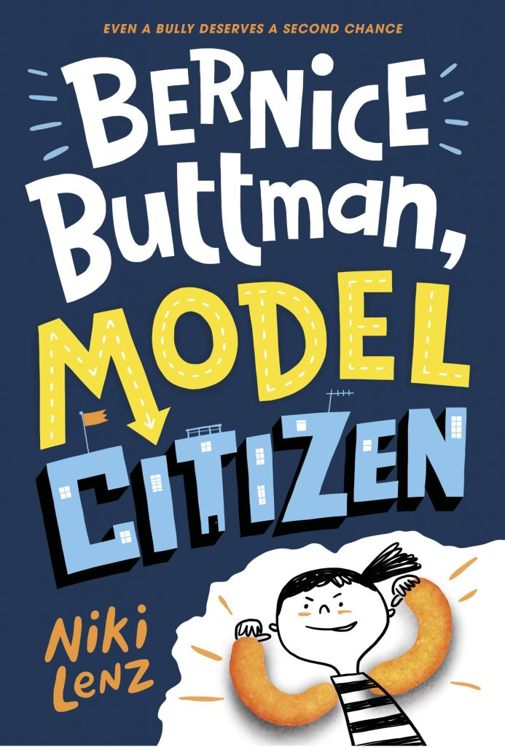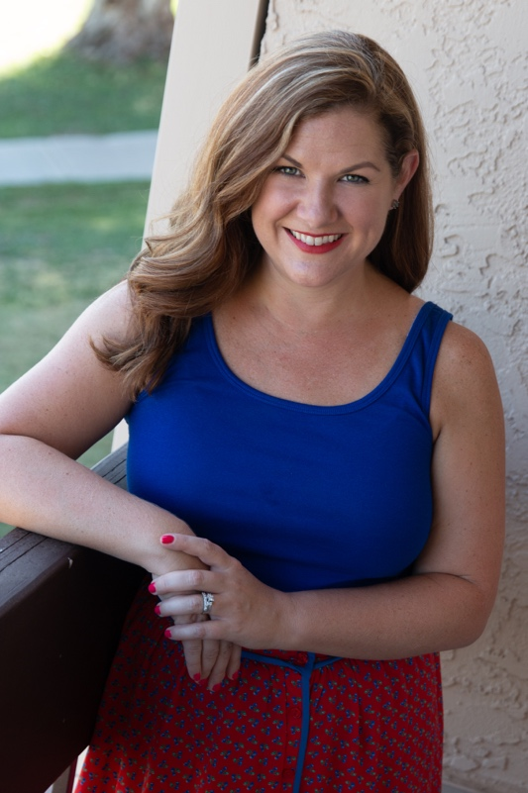

Niki Lenz, author of BERNICE BUTTMAN, MODEL CITIZEN and TEAM GRAVY will be visiting our school on ___________________________________!

Copies of her books will be available for purchase for _____________________, Please stop by to have your book autographed and to say hello!

**Niki Lenz**

**Author Visit and Book Signing**